Global Environment Facility
PDF BLOCK B REQUEST

Project Name: Renewable Energy Enterprise Development (REED)
GEF Focal Area: Climate Change
GEF OP: OP6 (Promoting the Adoption of Renewable Energy)
Geographical scope: Global: Nicaragua, Honduras, Zambia, Tanzania (Preliminary List)
Implementing Agency: United Nations Environment Programme/ Division of Technology Industry and Economics
Executing Agency: United Nations Environment Programme
Regional Development Banks
E+Co
Project Duration: 5 years
Total Cost of PDF-B: $450,000
PDF Funding Request: GEF: $ 300,000
PDF Co-financing: UN Foundation $ 30,000
W. Alton Jones Foundation $ 50,000
E+Co/USAID (FENERCA) $ 30,000
UNEP $ 40,000

PDF/A Grant Awarded: Not requested
Est duration of PDF-B: 9 months
Est Start date of Full Project: To be determined
Est Total cost of Full Project: To be determined
SUMMARY
Adopting a method developed by E+Co of coupling enterprise development services with modest amounts of start-up financing, UNEP’s Renewable Energy Enterprise Development (REED) initiatives are aimed at seeding a new breed of enterprises that apply “best-practice” approaches to supplying clean and affordable energy services to under-served populations. The experience to date has been that the combination of seed capital and enterprise development services, provided through an intermediary market facilitation organisation is an effective way to stimulate new enterprise development. Seeding new and innovative clean energy enterprises is a means to both improving energy access while reducing GHG emissions and other environmental degradation.
The early results have been promising and successful achievement of a sustainable environmental alternative is proposed. The project proposed involves establishing a mechanism by which young innovative energy enterprises can gain access to seed and patient capital support, and then link to more commercial investors and lenders as and when appropriate. In this regard, the proposed project complements existing GEF initiatives such as the IFC’s Renewable Energy and Energy Efficiency Fund by helping build the pipeline of enterprises that these funds are looking to invest in.
For background information on this work, please see the Concept Paper Renewable Energy Enterprise Development submitted to GEF council and approved for pipeline entry on May 9th, 2002.

- PROJECT OVERVIEW
The proposed project will establish a clean energy enterprise development facility comprising a number of seed and patient capital support mechanisms and corresponding enterprise development services. Together these mechanisms will provide clean energy entrepreneurs with the support needed to turn innovative ideas into concrete business plans, and for the more promising plans to start pilot operations and eventually grow to the point they can secure finance from commercial sources.
The facility will offer the opportunity to aggregate a variety of resources – grants, loans, investment, and so on – and organise these into distinct regional mechanisms with their own identities. The facility will provide programme management, monitoring and evaluation to donors, lenders and investors. Finally, the facility will be organised to achieve the maximum reasonable leverage on funds provided by aggregating like interests and arranging co-financing opportunities.
The structuring of the REED facility will be developed during the project preparation phase, as will the co-financing activities that bring social investors, regional banks and donor agencies in as partners in the different regions. This effort will be a prototype that, if successful, could lead to an expansion of sustainable energy financing through the REED approach, either by the GEF, financial institutions, social investors or bilateral donors.
An indicative list of REED activities include:
- Identification and training of new ‘pre-commercial’ clean energy entrepreneurs.
- Provision of tools to entrepreneurs for fact-finding, feasibility analysis and business planning.
- Provision of support services and seed capital to entrepreneurs with promising project and company ideas and works-in-progress.
- Provision of 2nd stage patient capital as core ideas mature in order to prepare these entrepreneurs for additional (conventional) risk capital, commercial debt and equity.
- Engagement of financial institutions and investors, the formulation and management of specialized finance mechanisms and the directing of public sector support to such efforts.
- Identification of existing and candidate market facilitation organizations in targeted countries, provinces and states to embrace and refine the model to local circumstances.
- Government interaction on targeted project (enterprise) and counterpart development related policies and procedures.
- Monitoring and evaluation of enterprise, counterpart and program management; course corrections and adaptations as appropriate.
- Aggregation of related businesses and investments into “umbrella” companies or associations to increase the investment grade, influence and growth of this sub-sector.
The development objective of this project is to lay the foundations for the provision of energy services to under-served households, businesses and communities in developing countries through:
- Creating locally appropriate energy enterprises, each offering some new form of sustainable energy service
- Transferring enterprise development expertise to local organisations
- Building in-country capacity amongst government policy makers to support the approach
- Stimulating private and public sector capital formation in support of these enterprises as they grow and mature, and
- Disseminating the approach to other multi and bilateral institutions.
The bulk of the GEF resources will be targeted at the creation of seed and patient capital funding mechanisms, along with the matching enterprise development support needed to build and refine the pipeline of viable projects, and the institutional strengthening required to replicate the most successful business models across the energy sector. How these funds can best be used will vary somewhat by region. In Central America, where the finance sector is more developed, project resources may be used to create a patient capital funding mechanism, whereby GEF resources are used to buy down risk through a blended co-financing arrangement with commercial investors. In Africa the funds will be structured according to a more constrained local context, however will still look to leverage bilateral sources of financing with that provided by local and regional development finance institutions. PDF B project development support will allow the regional project development teams to 1) assess the pipeline of enterprises seeking support, 2) conduct stakeholder consultations, 3) prepare regional REED facility business plans, and 4) raise co-financing.
Project development funds will also be used to determine how best to build local enterprise development capacity in the host countries and the types of support needed amongst policy makers to foster the REED approach.

The project will be developed for a number of countries, initially comprising: Honduras and Nicaragua in Central America and Tanzania and Zambia in Africa. This list should grow as programme planning goes forward, with the countries with UNF sponsored REED initiatives of particular interest (Ghana, Senegal, Mali, Brazil, China).

PROPOSED PDF/B ACTIVITIES

A project management team will be designated to oversee the overall project and regional project development teams will be charged with developing regional activities within the project. Although one general approach will apply to all regions, each will involve developing activities adapted to the national context, based on the needs of the energy sector and readiness of the local finance institutions to invest in sustainable energy enterprises.

2.1 Background Review of the REED Approach
2.1.1 Assessment of Non-Financial Returns on Investment

Initial anecdotal evidence suggests that REED-type investments can generate significant non-financial benefits. The background review of the REED approach will thus include an assessment of non-financial benefits associated with enterprises that have secured E+Co and REED financing.. Specifically, the study will emphasize the less tangible impacts of energy enterprises on subsequent industry-wide growth, institutional capacity for replication and the contribution of these effects to the overall sustainable development value of the approach. Data gathering will be done mainly through stakeholder interviews (with entrepreneurs, representatives of financial institutions, government, non-governmental and international development agencies) and document reviews. Analyses will be largely qualitative, complemented by statistical analyses of macro-economic, environmental, social and other non-financial outcomes and trends as needed. This work will also set a standard for the monitoring and evaluation of such activities.

Review of the Institutional Context for the REED approach in Target Countries
An enabling institutional framework that supports the implementation of REED-type enterprises and favors replication of the more successful approaches across the energy sector is important for project success. Therefore the preparatory work will include an assessment of the institutional context in each country for REED investments. In terms of absorptive capacity, such a review will also seek to identify institutional pathways and specific interventions that will facilitate the integration of the REED approach into the national energy sector decision-making process. Possible interventions include the identification of public-private partnerships; awareness-building targeting institutional players; and institutional barrier identification and removal.

2.2 Creation of Regional Project development teams
Teams will be charged with the planning and development of proposed REED funding mechanisms in each region, most of which would use GEF funds to leverage financing from regional/local financial institutions and investors. Each regional team will be comprised of experts from UNEP, E+Co, enterprise development NGOs and local stakeholders.
2.3 Stakeholder Consultations
The regional teams will carry out a set of consultations with the stakeholder groups - finance institutions, renewable energy companies, electric utilities and government agencies – to assess the needs for renewable energy financing and discuss ways in which currently valid, demand-driven and targeted support mechanisms can help enterprises scale up operations and eventually access commercial capital. Stakeholder consultation workshops will be held in each country to assess the need for and relevance of the proposed GEF sponsored activities, and to build partnerships with interested parties. Each workshop will be oriented towards achieving better coordination and complimentarity amongst different players. Stakeholder consultations will also ensure that any proposed REED mechanism responds to local and current conditions and is a catalyst that will contribute to the scale-up of financing to this sector.

2.4 Pre-Feasibility of Regional REED Funding Mechanisms
Based on the stakeholder consultations, the regional teams will prepare activity briefs for a number of funding mechanisms to include in the REED facility. Each brief will include a pre-feasibility analysis that reviews the applicability of the proposed mechanism to the needs of clean energy enterprises in the target region, and lays out the proposed structure for implementation.

2.5 Partnering with Financial Institutions / Raising Activity Co-financing
The initial partners targeted for this project will be regional multilateral finance institutions, including InterAmerican Development Bank, InterAmerican Investment Corporation, Corporacion Andina de Fomento and Central American Bank for Economic Integration for Latin America, and African Development Bank and Development Bank of Southern Africa for Africa. The partnering process will seek out with each institution programmes on which to build REED seed and/or patient capital facilities (e.g., rural development funds).

The structuring of these funding mechanisms might vary, depending on the willingness of financial institutions to lend/invest in RE enterprises, however the general criteria will be as follows:
- Innovativeness of financial structure
- Leverage of bank/investor co-financing
- Enterprise investment criteria sought by the financier

2.6 Selection of Most Promising Proposals
Mid-way through the PDF process the project management committee will select the most promising proposed mechanisms put forward by the regional project development teams based on the criteria of: innovation; applicability to the needs of local entrepreneurs; proposed finance partners (including both their commitment to integrating renewable energy enterprise finance into their operations and their direct leverage of GEF funds). Further project development funding will be provided to the regional teams for the selected mechanisms.

2.7 Business Plan Preparation for Each REED Mechanism
Once agreements have been reached in principle to partner in this activity, regional teams will work with the financial institutions in preparing business plans or prospectus for internal bank approvals. This work will also seek agreement in principle on financing terms and modalities (e.g., investment hurdles) that could meet the aims of the financial institution, GEF and REED partners.

2.8 Preparation of Preliminary Enterprise Pipelines
Preliminary enterprise pipelines will be prepared for each proposed funding mechanism. Preparing the pipelines will build off of consultations with clean energy entrepreneurs and will detail the financial model, projections, development plan and financing needs for each enterprise. This work will build off of the pipelines already developed through the Finerca programme in Central America and AREED in Africa.

2.9 Development of the Project Brief and Project Document.
A full project brief will be prepared based on the most promising activities developed in each region.

PDF OUTPUTS

3.1 Project Structure and Approach

The principal participants will prepare the following: (1) in-depth analysis of the REED approach, (2) comprehensive business plan and terms of reference for the creation of the REED facility, including schedule and budget, which will identify the roles and responsibilities and products of key participants (3) identification of participating countries and of country needs, (4) country endorsements from the GEF focal points, (5) and identification of project partners and their roles and responsibilities.

3.2 Project Brief
A detailed Project Brief will be prepared and submitted for review prior to the final project meeting.

3.3 Project Document
Subject to the approval of the project brief, a full project document will be prepared.

3.4 Co-financing Arrangements
The project will seek co-financing from regional development banks, private lenders and investors, equity funds, financial institutions, foundations, bilateral development agencies, and others. In each country/region, the project will consult closely with potential investors and lenders, including the private sector, the regional development banks (listed in 5.3.2).

JUSTIFICATION FOR THE PDF/B GRANT
The proposed project is unique in its scope and therefore will take quite some time and effort to develop. The goal is that GEF resources will be used to catalyse the creation of innovative “upstream” finance and support mechanisms for accelerated enterprise development in the sustainable energy sector.

As a global initiative the project needs to build a practical partnership of several organizations at the global, regional, and national levels. The PDF/B grant will be used to consult with stakeholders; prepare the business proposal for the finance mechanisms; prepare the initial pipeline of enterprises; and bring together the potential partners/co-funders for the project. The outputs from this preparatory work will provide to GEF Council a complete set of project activities, with detailed implementation plans, partners and co-financing.

Regions and countries of interest have been identified above but during the execution of work under this PDF/B, target countries and/or areas will be firmed up based on a significant investment potential for renewable energy companies resulting from a need for additional generation capacity, opportunity to displace fossil fuel use, an investment environment compatible with the needs of private sector power development, and national or provincial government interest possibly including co-investment of public funds.

PDF IMPLEMENTATION ARRANGEMENTS
This project will be conducted under the overall leadership and coordination of UNEP. UNEP will establish a Management Committee chaired by UNEP and with participation by E+Co, local NGOs and regional development banks.

Timing in Months after PDF/B approval
Meetings and Tasks
Meetings and Tasks | 1 | 2 | 3 | 4 | 5 | 6 | 7 | 8 | 9
Programme Management meetings
Creation of Regional Teams
Background Review
Stakeholder Consultations (+ Workshops)
Regional REED Activities Development
Preparation of Activity Briefs
Raising Co-Financing, Preparing Business Plans and Pipeline Development

Preparation of Final Project Brief

Budget ( all in k$US)
Activity | GEFª | Other | Total
Background Review | 40 | 15 | 55
Country Institutional Assessments | 30 | 15 | 45
Stakeholder Consultations (including four workshops) | 65 | 30 | 95
Pre-Feasibility of REED Funding Mechanisms | 25 | 25 | 50
Partnering with Financial Institutions / Raising Co-Financing | 25 | 25 | 115
Business Plan Preparation for each Mechanism | 50 |  | 50
Preparation of Preliminary Enterprise Pipelines | 40 | 40 | 80
Prepare Final Project Brief and Document | 25 |  | 25
Totals | 300 | 150 | 450
ª including all travel, meetings, and consultant costs

- COUNTRY OWNERSHIP
The approach responds directly to the priorities to support sustainable development set by host countries, specifically as shown by: direct feedback from governments in the related programs already underway; energy sector plans; and recommendations from international meetings and reports. Although many non-Annex 2 governments are starting to understand the issues underlying climate change, they usually lack the resources to make the required adjustments. Many governments believe the development of the private sector can help initiate some of the required changes.
Each of the initially proposed countries offer an environment within which the initiative can have the most impact – both in demonstrating to policy makers the types of clean energy enterprises that are viable and sustainable, as well as directly addressing their urgent need for the accelerated take-up of sustainable energy initiatives.
- SUSTAINABILITY AND Replicability
The sustainability and replicability of the project will be addressed at both the enterprise and program levels.
Each REED enterprise offers some new form of environmentally sound energy service – such as fee-for-service PV electrification, water pumping or solar crop drying - in a commercially sustainable manner. The provision of enterprise development services and seed and patient capital financing should usually be sufficient to either get a project to sustainability, or at least adequate maturity to attract subsequent commercial investment. Not all projects will succeed, however those that do will usually leverage outside financing during later stages of development and will thus be able to serve a significantly larger customer base than less commercially focused demonstration projects.
In terms of replicability, supported enterprises are generally innovators in their field; when successful, they broadly influence the creation of new markets, new industries and new approaches to the delivery of sustainable energy services. For example many of E+Co’s earlier investments, such as the PV companies Soluz, Selco and Grameen Shakti have had a major impact on the development of the renewable energy sector. Much of the benefit from these companies’ early efforts have accrued to the industry, through diffuse replication effects.
At the programme level, the effort will endeavor to transfer the energy enterprise development approach to local partners, in order to expand the institutional base for this sort of activity and to prepare these partners for accessing future support through other channels. If multi-/bilateral and other donor agencies can be shown that the approach is an effective manner in which 1) to help foster the clean energy sector, 2) to catalyze commercial co-investment in this sector and in so doing 3) to increase access for the rural poor to clean energy services, then the sustainability and institutional replication of the approach should be assured.

- Implementing Agency core commitments and linkages
Although renewable energy technologies are now coming of age, their commercialisation is still slow, especially from an environmental perspective. In response, UNEP has increased its efforts to ‘green the finance sector’, particularly focusing on promoting investment opportunities in the renewable energy and energy efficiency sectors. This includes on-going activities within UNEP’s Finance Initiatives, which today include 179 banks and 88 insurers as signatories, and the GEF-financed RE/EE Investment Advisory Facility (IAF). The IAF assists financiers in evaluating prospective investments in clean energy projects and funds in developing countries. To date the IAF has supported the development of three commercial funds, the IDB/MIF Latin American Energy Services Fund, the UBS Alternative Climate Fund and the Nepalese Clean Energy and Infrastructure Development Fund. How to catalyse the earlier stage development of sustainable energy projects, to get them to the commercially viable stage required by these funds and others, has become the new challenge, the one that REED activities seek to address.
The project will therefore contribute to the implementation of energy sub-programme 1: promoting renewable energy and efficiency technologies; it as well will support UNEP’s efforts to promote regional and international co-operation regarding global climate change, particularly mitigation measures.
The project is also consistent with UNEP’s strategic partnership with the GEF in that it can provide information on new approaches to clean energy services delivery through the recently established SustainableAlternatives.net (SANet).
Apart form UNEP, other GEF IAs and bilateral donor agencies could benefit from the project through:
- the opportunity to institutionalize an innovative enterprise development methodology with benefits beyond the renewable energy field;
- a new approach for working more directly with the private sector on clean energy issues, and
- closing the loop between high level policy work and ground level implementation activities (e.g., gaining experience on the type of currently feasible, market driven projects that are applicable to the Clean Development Mechanism).
- GEF Projects THAT Influence REED Activities
The REED initiative complements well a number of GEF projects that aim to promote market penetration of renewable energy technologies, including the Renewable Energy and Energy Efficiency Fund (REEF), the Solar Development Group (SDG) and the Small- and Mid-Scale Enterprise Programme (SME). These are primarily financing initiatives whose ultimate success will depend on the existence of a pipeline of well structured, viable RE businesses of the type REED will be developing. REED will look to hand-off its successful enterprises to these initiatives, and others like them, for later stage financing. Other relevant GEF projects will also be contacted during project preparation, including those ongoing in the proposed regions of intervention, including: Renewable Energy-Based Electricity for Rural, Social and Economic Development in Ghana; Household Energy in Mali; Sustainable and Participatory Energy Management in Senegal; and Biomass Power Commercial Generation in Brazil.

ANNEX 1: Related INFORMATION

- African Rural Energy Enterprise Development (AREED):
- Website: www.areed.org
- Brochure: http://www.areed.org/docs/areed_brochure.pdf
- Brazil Rural Energy Enterprise Development (BREED): www.b-reed.org
- E+Co: www.energyhouse.com
- UNEP Division of Technology, Industry and Economics
- Energy Group: www.uneptie.org/energy/
- Finance Initiatives: www.unepfi.net
- RE/EE Investment Advisory Facility: http://www.uneptie.org/energy/IAF/
- UN Foundation, Sustainable Energy and Climate Change program:
www.unfoundation.org/programs/environment/PF_climate.asp

ANNEX II: COUNTRY RATIFICATIONS OF THE UNFCCC

Country | Date of Signature | Date of Ratification | Entry into Force
Honduras | 13 June, 1992 | 19 October, 1995 | 17 January, 1996
Nicaragua | 13 June, 1992 | 31 October, 1995 | 29 January, 1996
Brazil | 4 June, 1992 | 28 February, 1994 | 29 May, 1994
Ghana | 12 June, 1992 | 6 September, 1995 | 5 December, 1995
Senegal | 13 June, 1992 | 17 October, 1994 | 15 January, 1995
Zambia | 11 June, 1992 | 28 May, 1993 | 21 March, 1994
South Africa | 15 June, 1995 | 29 August, 1997 | 27 November, 1997
Mali | 22 September, 1992 | 28 December, 1994 | 28 March, 1995
Tanzania | 12 June, 1992 | 17 April, 1996 | 16 July, 1996
China | 11 June, 1992 | 05 January, 1993 | 21 March, 1994

ANNEX III: SAMPLE OF E+Co/REED PROJECTS

Enterprise Name, Country | Business Activity | Project Description | Financing  E+Co/  AREED  [other] | Second Stage Investors | Achievements
E+Co Investments
Soluz Dominicana,  Dominican Republic | Solar Rural Electrification, using a PV leasing model. | PV leasing company that provides energy services on an affordable monthly basis  http://www.soluz.net/ | $300,000 loan  [$835,000] | Calvert World Values Fund, EEAF and Sunlight | Its approach is recognized as highly innovative and is being imitated in many countries.
Empresa Eléctrica del Norte (EEN),  El Salvador | 5 MW Biomass | Independent power producer, with 5 MW generating capacity fueled by bagasse. | $75,000 loan  [$7.2 million] | Banco Agricola Comercial, & CABEI | First thermoelectric plant in Central America to rely completely on biomass resources. Plant became operational in 2000.
Noor Web, Morocco | Solar Rural Electrification, using a franchising model | Energy services company providing PV installation and after sales services in rural areas and support to village-level solar entrepreneurs | $250,000 equity  [$750,000] | Shell Solar,  Two Moroccan industrialists. | 2,000 SHS financed and installed as part of 15,000 SHS partnership with National Electric Utility (ONE). Attained profitability in 2001.
Kanata Hydro Electric,  Bolivia | 7.4 MW high head hydroelectric plant | The plant harnesses the outflow from a high-altitude water reservoir. | $250,000 loan  [$5.2 million] | GiroCredit, Austria, Cidre, Styrcon Ges | Plant has been operating near capacity since 1999, producing 23.6 GWh in the past year.
RAPS Energy Stores,  South Africa | Solar Rural Electrification delivery company | Establishes energy franchises that rent solar systems and provide service and maintenance.  http://www.raps.co.za | $243,895 equity and loan  [$1 million] | NUON,  Solar Development Foundation (SDF) | 50,000 SHS concession contract signed with ESKOM
CleanTHAI, Thailand | Waste to energy biogas systems | Develops methane gas recovery and waste-to-energy projects in the livestock and food & beverage sectors. | $150,000 equity  [$1.4 million] | REEF, Al Tayyar | The first REEF project approved for investment .
AREED Investments
Rasma  Zambia | Mfc. Efficient Cookstoves | Company produces and sells efficient cook stoves. | $20,000 Equity | AREED projects began receiving enterprise development services in late 2000, and seed financing began being approved for these companies starting 2nd quarter 2001.
AME  Senegal | Maintenance of Solar Heating Systems | The provision of maintenance services for solar water heaters in the residential and commercial sector, both urban and rural. | $41,500  Local currency loan
ABM  Ghana | Power Factor Correction | Existing EE company that will develop power factor correction business. | $120,000  USD Loan
VEV, Senegal | Wind pumps | Servicing existing wind pumps in rural areas | $17,000 Local loan
USISS, Mali | Solar Crop Drying | Drying meats, mangoes and onions | $18,000 Local currency loan

ANNEX IV: COUNTRY ENDORSEMENTS
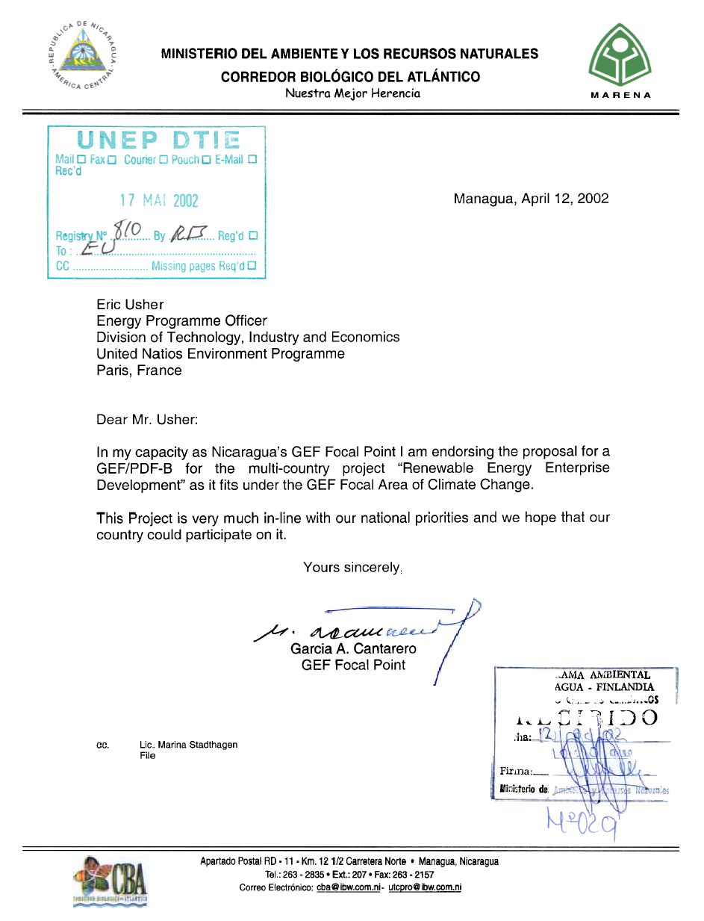

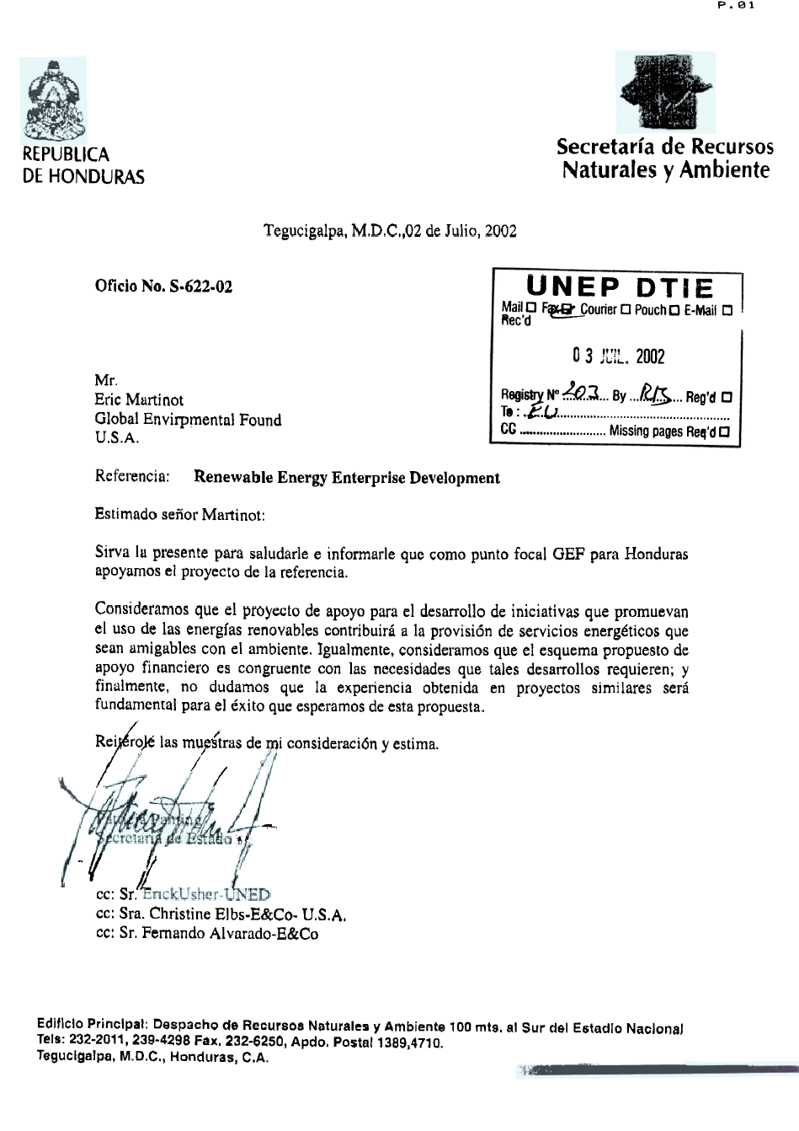
Translation:
As GEF Focal Point for Honduras, we support the project mentioned in the subject of this letter.
We consider that the project "Renewable Energy Enterprise Development" will contribute to the provision of environmentally-friendly energy services.
We also consider that the proposed strategy of financial support is in accordance with the need to address sustainable development.
Finally, we don't doubt that the experience already gained in similar projects will definitely contribute to the success of this proposal.
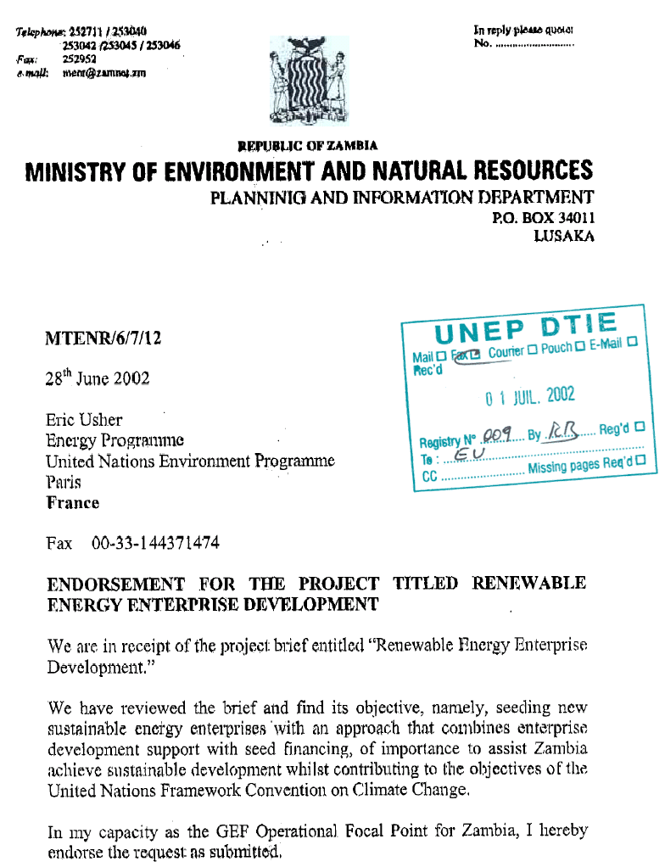
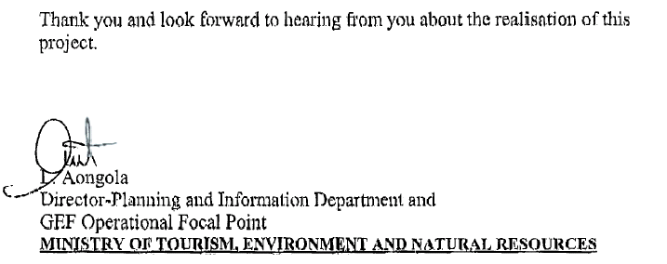
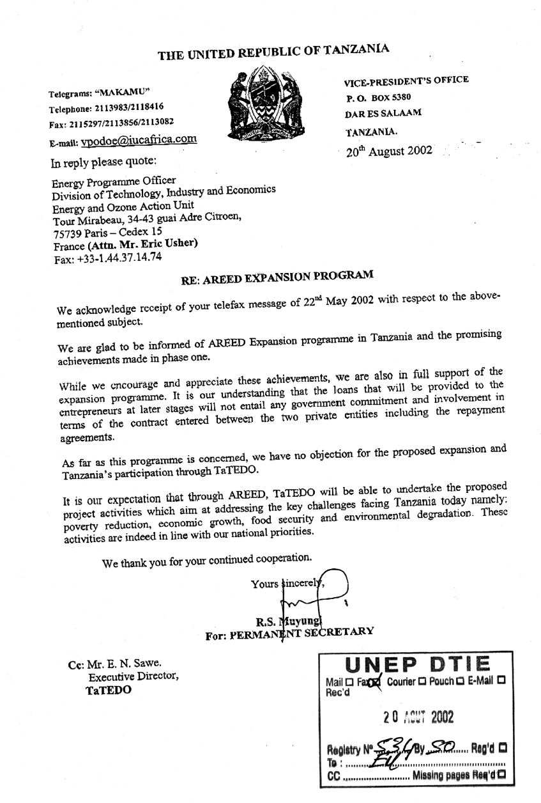

1 Africa REED has been working in Senegal, Mali, Ghana, Zambia, Tanzania and Botswana; a similar program is starting in Northeast Brazil and soon in Yunnan Province, China. Websites for these programs and the partner organizations involved are listed in Annex 1.
As defined in GEF Business Plan FY03-05 (Section A8.b).
A number of E+Co financed companies have indeed gone on to secure second stage financing from SDG, REEF and the SME programmes.
The potential benefits of each enterprise investment includes the direct financial returns typically of interest to the entrepreneur and their commercial backers, but also indirect returns such as improved rural livelihoods, increased supplier activities and induced returns such as replication and growth of the renewable energy sector in other regions.
Based on the experience of the project team in managing funding for energy enterprise development and pre-commercialisation activities, seeking early agreement with financiers on enterprise investment criteria is key. Otherwise, the drive to seek low risk and elevated financial returns can compromise the social and environmental dimensions of a project pipeline, or smoother any room for innovation. If the proposed funding mechanisms do not focus on promoting only innovative new approaches to clean energy services delivery then they will be failing the mandates of both the GEF and UNEP.
GEF Roundtable on Sustainable Energy (January 2002, NY); G8 Renewable Energy Task Force Report (2001, Case Study 12); the IPCC Working Group III, Methodological and Technological Issues in Technology Transfer, IPCC, 2000; Marrakech GEF Global PV Review Meeting Report, GEF, 2000.
See www.unepfi.net and www.unepfi.net/invent/isef/index.htm
See www.uneptie.org/energy/IAF/ Redirecting Commercial Investment Decisions to Cleaner Technologies, GF/2200-00-03.

